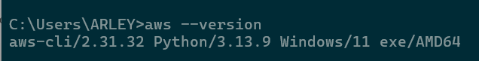
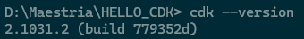

Ejecutando cdk init app --language java
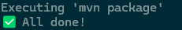

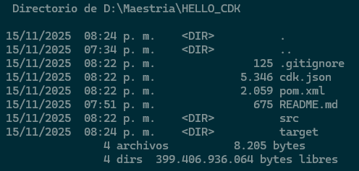
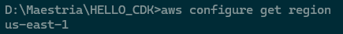
cdk bootstrap aws://638183328667/us-east-1
agregar YML bootstraptemplate

